# Udacity Project 2: Apartment

# Developed by : Helen Nichoslon

This project is part of [Udacity](https://www.udacity.com "Udacity - Be in demand")'s [VR Developer Nanodegree](https://www.udacity.com/course/vr-developer-nanodegree--nd017).

## Versions

- Unity 2017.1.0

- GVR Unity SDK v1.60.0

# Produced for ioS Iphone 7

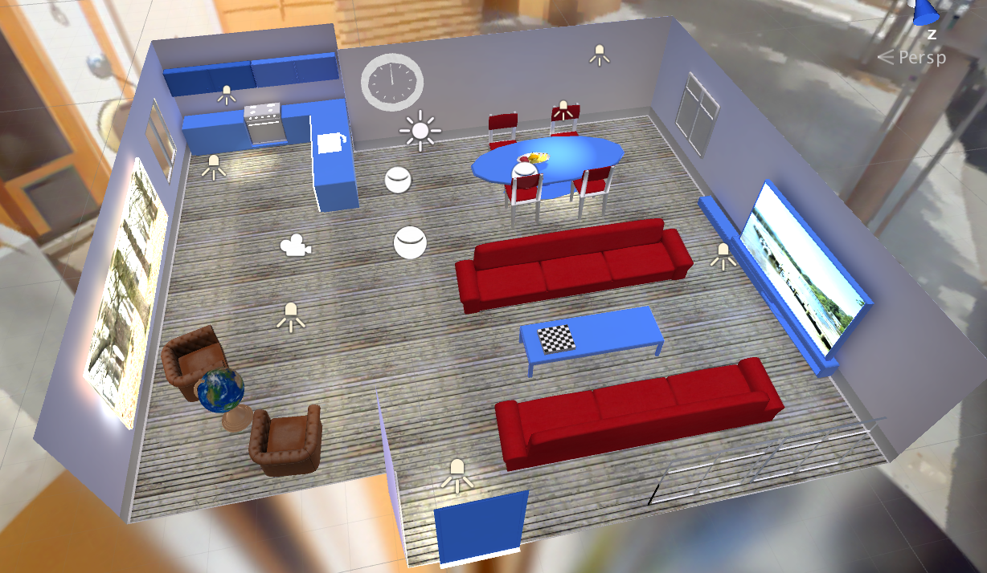

# Description

# Main Scene : Loft style apartment with a rotating globe, animated clock & background music in Google Cardboard VR mode (stereoscopic)

# Background :

# apartment scene with background music playing

consists of >20 3D models all marked as static. Includes : walls, flooring, ceiling, lighting, lounge area (3 sofas, coffee table & large TV with stand); dining area ( table, 4 chairs & fruit bowl); kitchen area ( wall & floor cabinets with microwave & sink with taps); 2 x comfortable arm chair, wall decorations (including clock & 2 pictures).

# Loft style

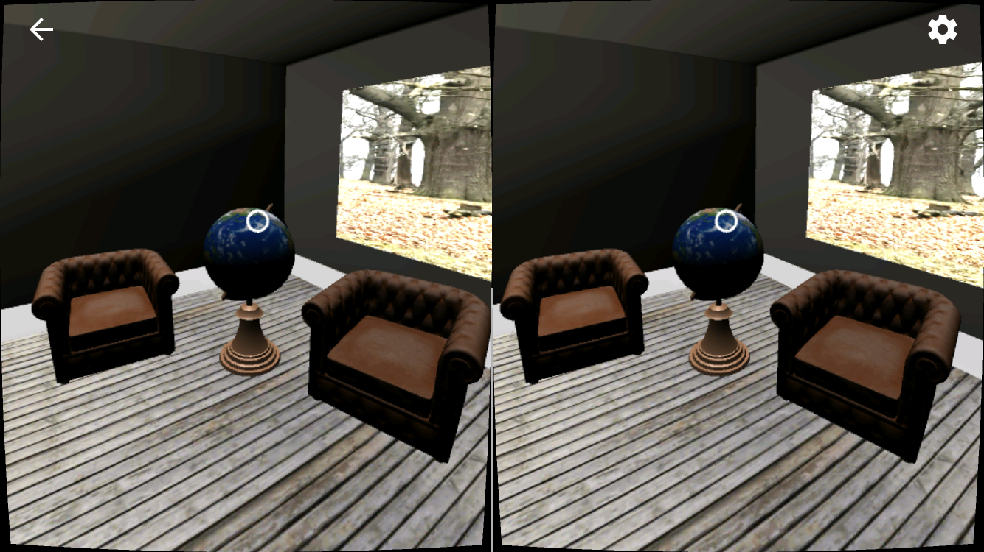

# Animaton : Globe is textured with planet map (imported sset). The globe rotates when clicked & will only stop when clicked again. Clock minute hand rotates.

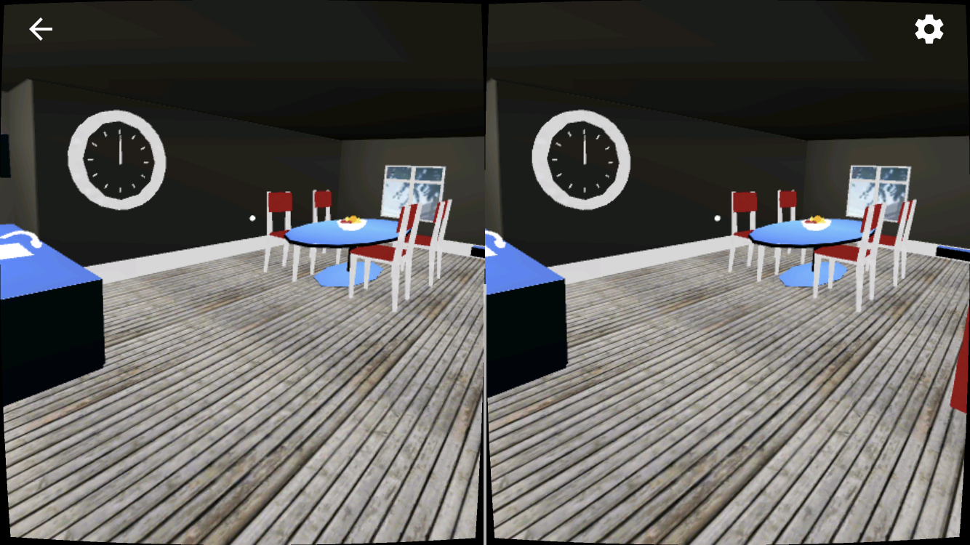

# The clock minute hand also rotates

# Wide angle view - main camera

# Assets used : as provied in UDacity project template with additions as below ..

# Imported Assets :

# Wooden Floor material  - Used Wooden Floor Pack from Unity Assets Store by Mikelarg / Version: 1.0 (Jul 21, 2015)

# Planet Earth texture map used on Globe : Planet Earth Free by headwards / Version: 2.0 (Mar 04, 2016)

# Lighting : includes directional light and spot lights. All lights are baked and none are realtime.

# Lightmap Settings: Precomputed Realtime GI off; Directional Mode : Non-Directional; Auto baking off; Bake resolution 80.

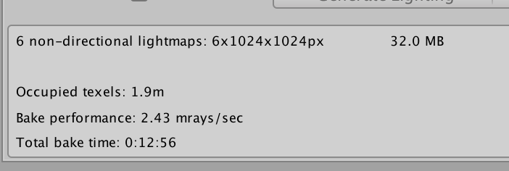

# Quality settings :  set to “Mobile”;  pixel light : 0; Texture Quality: Full Res; Anti Aliasing: 2x Multi Sampling; Shadows: Disable Shadows; Blend Weights: 1 bone. Following settings checked off : Soft Particles, Realtime rendering probes' 'Billboards face camera position.

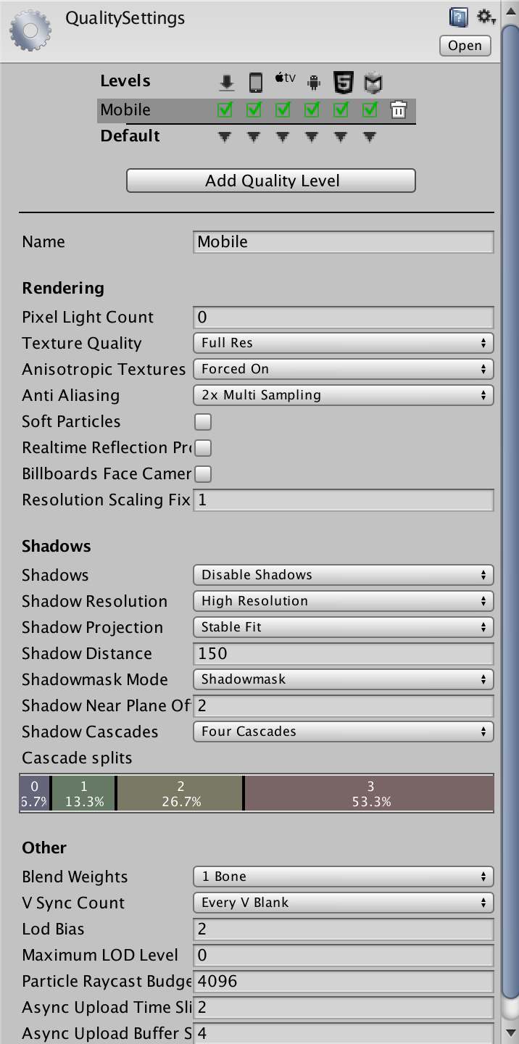

# fps run time - comfortably > 60 fps

# Developer notes :

#  Lighting was experimental & proved to have variable results

#  Issues with unwanted dark shadows from the bookshelf & books led to unchecking the bookshelf.

#  Enjoyed the project although I found dealing with unexpected results in lighting shadows quite a challenge.

# Did get a version working with music as well - fun !

# Achieved most of original aims in the end :-)

# Disappointed in quality of visual detail after baking lights and using mobile performance settings but project was interesting to do at this stage of Vr NanoDegree